Changes in the relative abundance of common pheasants (Phasianus colchicus) in relation to protected areas.
Joe A. Wilde, Luke Ozsanlav-Harris & Joah R. Madden.

1 Abstract
Millions of common pheasants (Phasianus colchicus) are released for shooting annually in the UK. Management aims to keep the majority of birds within the bounds of the shoot but dispersal into the wider landscape can occur, especially when management decreases after the shooting season. Pheasants may be attracted to protected areas as they may provide respite from shooting and may provide suitable habitat for overwintering and/or breeding. Using survey data from four county bird atlases during 2007-2011, we assessed whether there were shifts in pheasant abundance towards areas with high protected area coverage, and whether this shift is consistent between winter and the breeding season, as well as across counties. We used an occupancy-abundance model to examine the relationship between relative pheasant abundance and protected area coverage. We found a negative relationship between relative pheasant abundance and protected area coverage that was consistent between winter and the breeding season across all counties, suggesting that pheasants do not use preferentially use protected areas as refuges and/or overwintering/breeding sites. This may be due to current gamebird release restrictions surrounding some types of protected areas leading to lower pheasant abundance within those areas. This suggests that ecological change caused by pheasants is no more likely, and possibly less likely to occur in protected areas.

2 Introduction
Common pheasants (Phasianus colchicus) are released across the UK in late summer/early autumn for shooting, the season for which runs from October until February. After release, pheasants can move away from the release sites (Hill and Ridley 1987) but game management aims to keep the majority of pheasants within areas where shooting will take place (Game Conservation Trust, 1996). Protected areas (special areas of conservation, sites of special scientific interest, special protection areas) may be attractive to dispersing individuals, providing a refuge from shooting activities or providing suitable wintering/breeding habitats. Such immigration may be concerning because of the ecological change that these birds may exert via nutrient enrichment through defecation, predation of local native fauna, trampling damage to flora, being potential vectors of disease, and supporting local abundances of generalist predators (Madden and Sage 2020; Mason et al. 2020; Sage et al. 2020). It is therefore important to determine whether released pheasants preferentially disperse into protected areas to determine how ecological change may be caused.
One way to assess whether released pheasants are moving into protected areas is to examine whether there are shifts in the relative abundance of pheasants from areas where they are released and retained by game management (late-summer to late winter) towards protected areas in the breeding season (late spring/early summer when shooting and game management has predominantly ceased).
During 2007-2011, the BTO organised volunteer surveys of all UK birds at the tetrad level (2km x 2km squares) during the winter (November to February) and breeding season (April to July; Balmer et al. 2013). Fieldwork for the survey was carried out in four winters (2007/08–2010/11) and four breeding seasons (2008–11) with a pair of standardized visits to each tetrad in each of the eight survey periods (for more details on the methodology see Balmer et al. 2013; Gillings et al. 2019). These data provide an abundance estimate for pheasants during the winter and breeding season, allowing for comparison between these two time periods. Between winter and the breeding season, the number of pheasants will have decreased overall due to shooting and natural mortality to approximately 15% of those released (Madden, Hall, and Whiteside 2018). Therefore, we are interested in changes in relative abundance, which allows us to account for changes in population size due to mortality and releases. If pheasants are dispersing towards protected areas then we would expect a positive relationship between protected area coverage and relative pheasant abundance. This positive relationship may be consistent across both winter and the breeding season, suggesting protected areas are attractive to pheasants despite efforts from game management to limit pheasant dispersal. However, this positive relationship may only be present during the breeding season (i.e. there may be an interaction between protected area coverage and time period), when efforts by game management to limit pheasant dispersal has ended.

3 Methods

3.1 Pheasant abundance data
Several UK counties conduct tetrad surveys of their bird fauna and publish their results. We collated data from four counties who published their atlases online. Berkshire (http://berksoc.org.uk/county-atlas/), Cornwall (https://atlas.cbwps.org.uk/), Devon (http://devonbirdatlas.org/) and Hertfordshire (http://www.hertsatlas.org.uk/). For each of these atlases, the abundance of birds in 2km² tetrads during the breeding season (April to July) and winter period (November to February) was recorded following methods used by the British Trust for Ornithology (BTO) as part of their Atlas surveys (Balmer et al. 2013, Gillings et al. 2019). In Berkshire, data were collected from 394 tetrads between 2007 and 2011. In Cornwall, data were collected from 1050 tetrads between 2000 and 2009. In Devon, data were collected from 1858 tetrads between 2007 and 2013. In Hertfordshire, data were collected from 491 tetrads between 2007 and 2012. Since abundance was reported differently in each county, we standardised abundance measures across counties to get continuous measures. For Devon, Berkshire and Hertfordshire, reported abundance data were categorical and these categories were different for each of the three counties. We therefore calculated the midpoint value for each category, meaning each tetrad had a single continuous value of abundance for winter and summer. Although this method allows us to analyse data from all four counties systematically and consistently, we acknowledge that using categorical measures in this way could be considered coarse. Abundance data were continuous for Cornwall and remained unaltered.

We were interested in changes in abundance relative to the total sample of pheasants alive in each county, accounting for these high levels of mortality and mass releases in late summer. Therefore, we calculated a relative abundance metric that accounted for the abundance of pheasants alive in a county in a season, taking into account the high levels of mortality from winter to breeding or the marked increases due to releases from the breeding season to winter. We converted all abundance measures into relative abundance measures using the following equation:
$$\begin{aligned}{A^{'}}_{i, c, s}= \frac{A_{i, c, s}}{\sum_{i=1}^{N_{c}}{A_{i, c, s}}}\#1\end{aligned}$$

where $A_{i, c, s}$ and ${A'}_{i, c, s}$ denote the absolute and relative abundance metric for the $i$th tetrad in county $c$ during season $s$, respectively. $N_{c}$denotes the total number of tetrads in county $c$. This relative abundance metric would be constant for a given tetrad between time periods if there is no net immigration or emigration and survival is constant across the county.
If pheasants are dispersing towards protected areas, then we would expect evidence of a positive relationship between this relative abundance metric and protected area coverage, or an interaction between the effect of protected area coverage and season on relative pheasant abundance. If this is the case, we would expect the effect of protected area coverage to be more positive in the breeding season than in winter (when pheasant dispersal is still being managed).

3.2 Protected areas
Across the four counties examined we calculated the proportion of each tetrad (n = 3442) covered by protected areas that were ecologically relevant to pheasants. We used the 2007 United Kingdom Centre for Ecology and Hydrology (UKCEH) land cover map (25m x 25m spatial resolution; Morton et al., 2014) to determine the dominant habitat type in each protected area. Protected areas were classified as ecologically irrelevant to pheasant and removed from subsequent analysis if the dominant habitat type was one of the following: ocean, saltwater, freshwater, saltmarsh, bog, urban, suburban, inland rock, supra-littoral sediment, supra-littoral rock, littoral sediment or littoral rock. This meant protected areas mostly taken up by the following habitat types were retained: broadleaf woodland, coniferous woodland, arable/horticulture, fen/marsh/swamp, heather, heather grassland, acid grassland, rough grassland, improved grassland, neutral grassland and calcareous grassland. These remaining habitats are where pheasants are most commonly found in breeding bird surveys (Heywood et al. 2023). Occasionally a single designated site was composed of multiple distinct and disconnected polygons. In these instances, each polygon was treated as an independent protected area.

3.3 Habitat data
We calculated the proportion of each tetrad covered by each of 10 aggregate habitat classes: broadleaf woodland, coniferous woodland, arable, improved grassland, semi-natural grassland, mountain heath & bog, saltwater, freshwater, coastal and built-up areas and gardens (Morton et al., 2014). We also calculated the Shannon diversity index for each tetrad. This is calculated as $H'= -\sum_{i=1}^{n}{p_{i}×ln⁡(p_{i})}$, where $p_{i}$is the proportion of each tetrad taken up by the $i$th habitat type, and $n$ is the total number of possible habitat types (Ortiz-Burgos, 2016). Higher values of $H'$ indicate more habitat types in a tetrad.
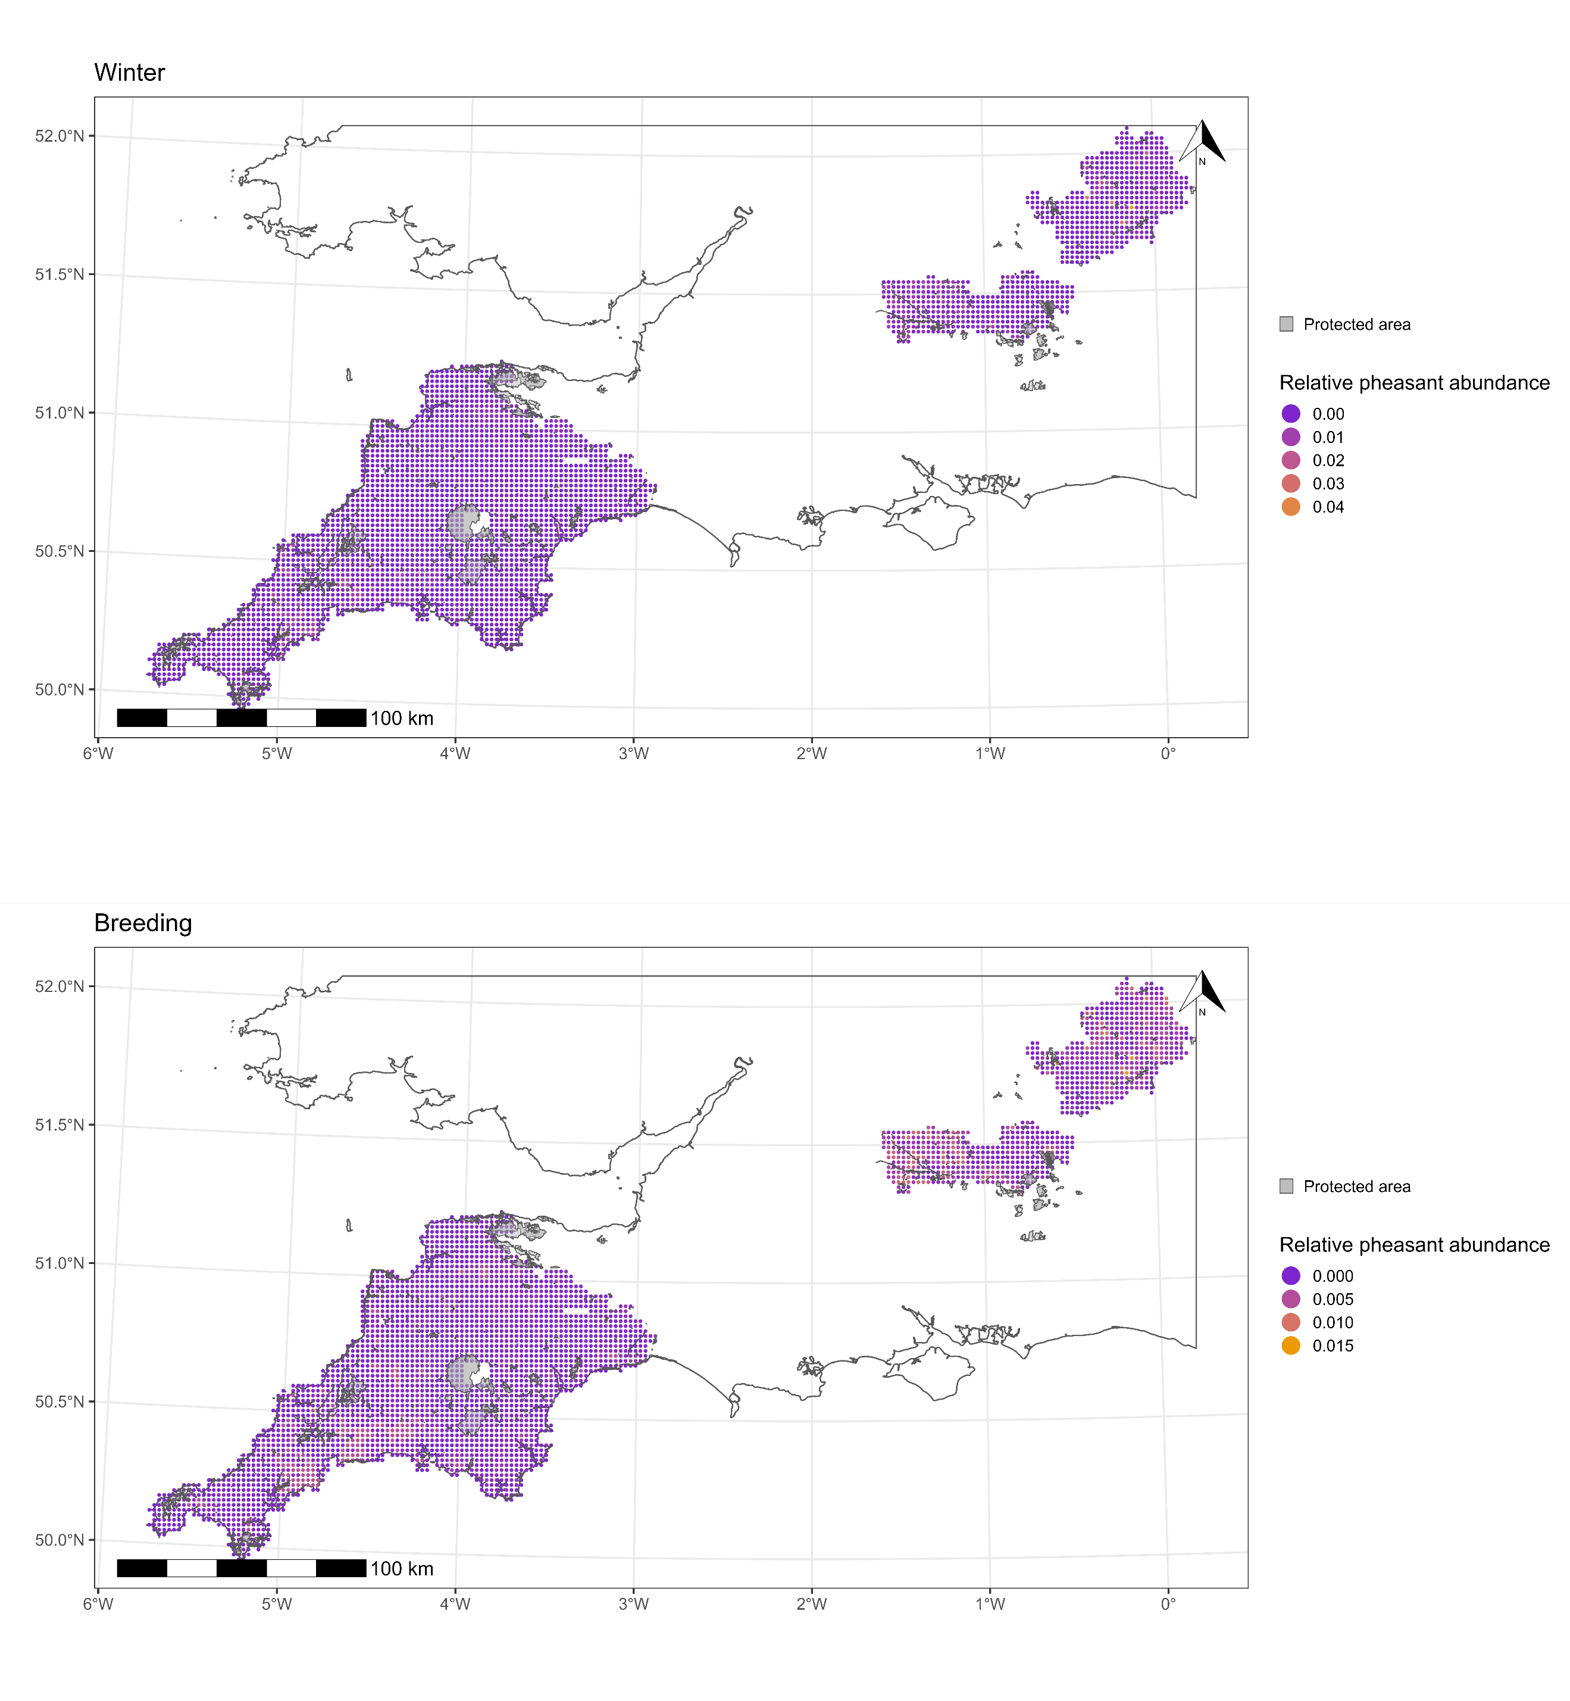Figure 1- the relative pheasant abundance of each 2km² tetrad in Berkshire, Cornwall, Devon and Hertfordshire in winter (top) and during the pheasant breeding season(bottom). Protected areas of suitable habitat are overlayed in grey.

3.4 Statistical analyses
To analyse the relationship between protected area coverage and the relative abundance of pheasants, we used an occupancy-abundance model in a Bayesian framework. These models are a mixture of occupancy models, which simultaneously estimate the probability a target species occupies a given area and a probability of target species detection, and abundance models, which estimate the abundance of the target species in occupied areas (here modelled using a Beta distribution; Bailey et al., 2014, Holt et al., 2002, Potts & Elith, 2006). We can also estimate the effects covariates have on pheasant abundance to determine what features of a tetrad causes pheasant abundance to increase or decrease. Using these models allows us to estimate and account for the probability that pheasants were present in a tetrad but were not detected during surveys, as well as a certain amount of spatial autocorrelation in the probability of pheasant occupancy.
The fixed effects included in the model were county (Berkshire, Cornwall, Devon, Hertfordshire), time period (winter/breeding season), the proportion of a tetrad covered by each of the 10 habitat types (detailed in section 3.3, one fixed effect for each habitat type), and the proportion of each tetrad covered by ecologically-relevant protected areas (section 3.2). We included a two-way interaction term between time period and protected area coverage, to determine if the effect of protected area coverage differs between the winter period and breeding season. We also included a three-way interaction between county, time period and protected area coverage to account for possibility that the effect of protected area coverage and its interaction with time, may be different for each county.
All models were written in Stan (Carpenter et al., 2017) and compiled using Cmdstan (Stan Development Team, 2018) and the cmdstanr package (version 0.8.0; Gabry & Johnson, 2023) in R (version 4.4.0; R Core Team, 2022) using RStudio (version 2024.09.0; RStudio Team, 2020). Weakly informative priors were used for all parameters, and model convergence was checked by inspecting trace plots and ensuring that the potential scale reduction factor ($\hat{R}$) ≈ 1. The 2.5% and 97.5% highest density limits (HDL) of posterior distributions are reported in square brackets throughout (e.g. [-0.01, 0.01]; Kruske, 2014, McElreath, 2020). More information on the priors used, as well as the full model output can be found in the supplementary materials.

4 Results

4.1 Counties
Relative pheasant abundance varied by county with Devon having the lowest relative abundance per tetrad (estimated mean relative abundance = [0.0005, 0.0006]) and Berkshire having the highest relative abundance per tetrad (estimated mean relative abundance = [0.0009, 0.001]). A summary of the estimated mean relative abundance for each county can be found in table 1.
County | 2.5% HDL of mean relative abundance | 97.5% HDL of mean relative abundance
Berkshire | 0.0009 | 0.001
Cornwall | 0.0006 | 0.0007
Devon | 0.0005 | 0.0006
Hertfordshire | 0.0008 | 0.0009
Table 1- the estimated mean relative abundance of pheasants for each of the counties included in the study.

4.2 Habitat type
The most prevalent effect on pheasant abundance was caused by the 10 habitat types. There were positive relationships between relative abundance and the proportion of a tetrad occupied by broadleaf woodland (β = [0.07, 0.15], see figure 2), and arable (β = [0.08, 0.18]). The proportion of each tetrad occupied by mountain, heath and bog (β = [-0.11, -0.006]), built-up areas (β = [-0.19, -0.10]), freshwater (β = [-0.07, -0.01]), and semi-natural grassland (β = [-0.11, -0.004]) had a negative relationship with relative abundance. A summary of the relationship between relative pheasant abundance and all 10 habitat types can be found in table 2.
Habitat type | 2.5% HDL of effect size | 97.5% HDL of effect size
Broadleaf woodland | 0.07 | 0.15
Coniferous woodland | -0.04 | 0.02
Arable | 0.08 | 0.18
Improved grassland | -0.05 | 0.05
Semi-natural grassland | -0.11 | -0.004
Mountain, heath and bog | -0.11 | -0.006
Saltwater | -0.03 | 0.04
Freshwater | -0.07 | -0.01
Coastal | -0.05 | 0.02
Built-up areas and gardens | -0.19 | -0.10
Shannon habitat diversity index | -0.03 | 0.04
Table 2 - shows the highest density limits (HDL) of the posterior distribution of the effect size of the proportion of each tetrad occupied by all 10 UKCEH land-use habitat types, as well as the effect of the Shannon habitat diversity index.
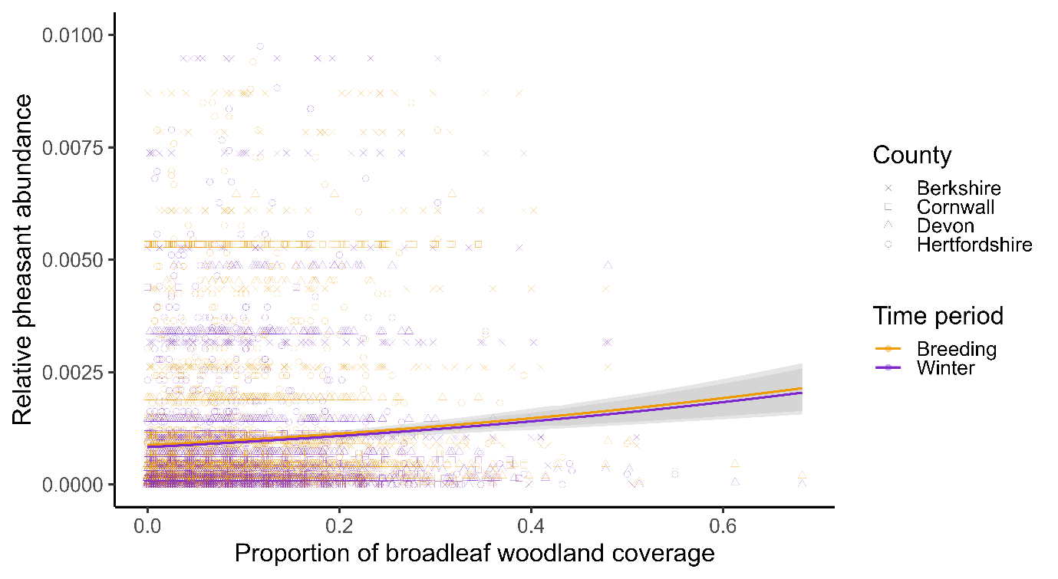
Figure 2- the raw pheasant relative abundance data (coloured points) and the model predictions for the relationship between the proportion of broadleaf woodland coverage and mean relative pheasant abundance (coloured lines). The grey shaded areas denotes the 95% highest density interval for each time period.

4.3 Protected area coverage
There was evidence of a negative effect of the proportion of each tetrad occupied by protected areas on pheasant abundance (β = [-0.12, -0.03], see figure 3). However, there was no evidence of a two-way interaction between protected area coverage and time period (β = [-0.81, 0.80]), suggesting the effect of protected area coverage is consistent between winter and the breeding season. There is also no evidence to suggest a three-way interaction between protected area coverage, time period, and county (see table 3).

Fixed effect | 2.5% HDL of effect size | 97.5% HDL of effect size
Protected area (PA) coverage | -0.12 | -0.03
Time period: Winter → Breeding | 0.01 | 0.04
PA coverage × Time period: Winter → Breeding | -0.81 | 0.80
PA coverage × Time period: Winter × Berkshire | -1.60 | 1.61
PA coverage × Time period: Winter × Cornwall | -1.46 | 1.45
PA coverage × Time period: Winter × Devon | -1.55 | 1.47
PA coverage × Time period: Winter × Hertfordshire | -1.42 | 1.42
PA coverage × Time period: Breeding × Berkshire | -1.68 | 1.70
PA coverage × Time period: Breeding × Cornwall | -1.48 | 1.45
PA coverage × Time period: Breeding × Devon | -1.37 | 1.57
PA coverage × Time period: Breeding × Hertfordshire | -1.38 | 1.44
Table 3- shows the highest density limits (HDL) of the posterior distribution of the effect size of the proportion of each tetrad occupied by suitable protected areas, the time period in which the abundance survey took place, as well as the two- and three-way interactions between protected area coverage, time period and county.
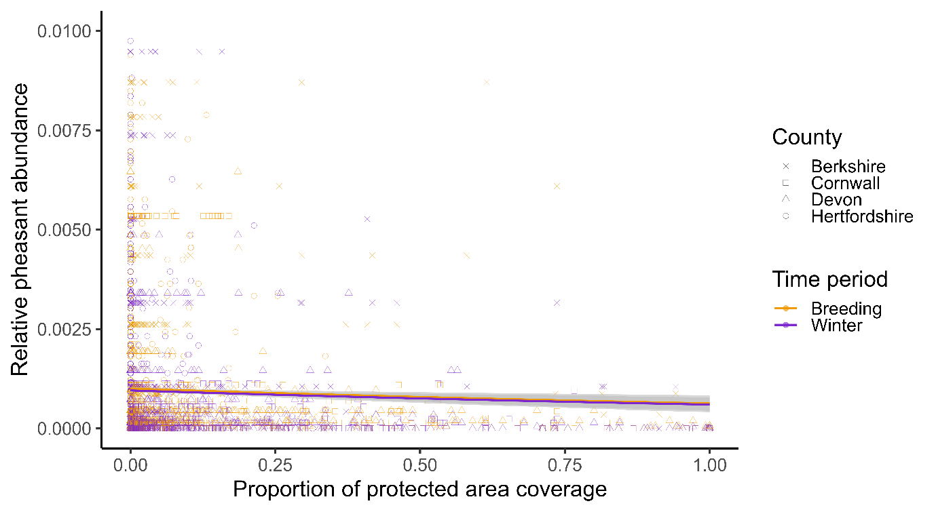
Figure 3- the raw pheasant relative abundance data (coloured points) plotted over the amount of each tetrad occupied by suitable protected areas. The predicted relationship between protected area coverage and mean relative abundance is shown (coloured lines). The grey shaded areas show the 95% highest density interval.
The full results from the occupancy-abundance model can be found in the supplementary materials.

5 Discussion
We used relative pheasant abundance measures calculated from tetrad survey data to determine if there was a relationship between pheasant abundance and ecologically suitable protected area coverage. We also investigated whether any relationship was consistent between seasons, and across counties. We did this to determine if there is any evidence suggesting pheasant preferentially disperse into protected areas, as this may cause ecological damage.
We found evidence of a negative relationship between protected area coverage and relative pheasant abundance. This negative relationship was consistent across all four counties included in the analysis, and across winter and the breeding season. This suggests that pheasants avoid dispersing into protected areas. This may be due to a higher biodiversity within protected areas (Cooke et al., 2023), meaning a higher generalist predator presence within protected areas also. However, the main predator of pheasants in the UK is the red fox (Vulpes vulpes), which has become increasingly urbanised within the last 35 years (Scott et al., 2014) and is unlikely to have a higher prevalence within protected areas than unprotected areas. Therefore, it is unlikely that pheasants are predated at a higher rate in protected areas (and so are recorded less in those areas), or avoid protected areas due to increased predation threats.
In the UK, a licence is required in order to release common pheasants or red-legged partridges (Alectoris rufa) within 500 metres of the boundary of a special area of conservation or special protection area, and the density of birds to be released within this buffer zones is limited (GL43, 1981). It therefore seems likely that tetrads with high protected area coverage also have lower densities of pheasant release occurring due to these restrictions. The negative relationship between protected area coverage and relative pheasant abundance we found may therefore be due to these release restrictions and may not necessarily reflect an active avoidance of protected areas at the level of released pheasants. To further investigate and control for this potential bias introduced by release restrictions, further work needs to be carried out using information on the number and density of pheasant releases occurring in each tetrad.
The relationship between each of the 10 habitat type coverages and relative pheasant abundance provide confirmation that the models used in this study are robust enough to detect and control for the relationships under investigation. The positive relationship between relative pheasant abundance and broadleaf woodland coverage and arable coverage is expected given that these habitat types are where pheasants are most often released and found (Robertson et al., 2017; Heywood et al., 2023). These results demonstrate that this broad-scale approach has been able to capture known ecological drivers of pheasant abundance.
The results of our investigation suggest that pheasants are not preferentially dispersing into protected areas at any time of year. Therefore, there is no evidence to suggest that any ecological change wrought by pheasants is likely to happen more in protected areas than non-protected areas. Furthermore, the current restrictions surrounding gamebird releases near protected area boundaries may mean that ecological change caused by pheasants may be less likely to occur in these areas. Future research should investigate whether these patterns hold at a finer spatial scale using information from known releases, as well as explore the implications of gamebird management practices for both pheasant populations and biodiversity within protected areas.

References
Bailey, L. L., MacKenzie, D. I., Nichols, J. D. (2014). Advances and applications of occupancy models. Methods in Ecology and Evolution, 5, 1269-1279. https://doi.org/10.1111/2041-210X.12100
Balmer, D. E., Gillings S., Caffrey, B. J., Swann, R. L., Downie, I. S., Fuller, R. J. (2013). 2007-11: The Breeding and Wintering Birds of Britain and Ireland. BTO Books, Thetford.
Carpenter, B., Gelman, A., Hoffman, M. D., Lee, D., Goodrich, B., Betancourt, M., Brubaker, M., Guo, J., Li, P., & Riddell, A. (2017). Stan: A probabilistic programming language. Journal of Statistical Software, 76. https://doi.org/10.18637/jss.v076.i01
Cooke, R., Mancini, F., Boyd, R. J., Evans, K. L., Shaw, A., Webb, T. J., Isaac, N. J. B. (2023). Protected areas support more species than unprotected areas in Great Britain, but lose them equally rapidly. Biological conservation, 278, 109884. https://doi.org/10.1016/j.biocon.2022.109884
Gabry, J., Cěsnovar, R., & Johnson, A. (2023). Cmdstanr: R interface to ’CmdStan’. https://mcstan.org/cmdstanr/.
Gillings, S., Balmer D. E., Caffrey, B. J., Downie, I. S., Gibbons, D. W., Lack, P. C., Reid J. B., Sharrock J. T. R., Swann, R. L., Fuller, R. J. (2019). Breeding and Wintering Bird Distributions in Britain and Ireland from Citizen Science Bird Atlases. Edited by Erica Fleishman. Global Ecology and Biogeography, 28, 866–74. https://doi.org/10.1111/geb.12906.
GL43: licence to release common pheasants or red-legged partridges on certain European sites or within 500m of their boundary. 1981. Sections 16(4) and 16(5).
Heywood, J. J. N, Massimino, D., Balmer, D. E., Kelly, L., Noble D. G., Pearce-Higgins J. W., Woodcock P., Gillings, S., Wotton, S., Harris S. J. (2023). The Breeding Bird Survey 2022. BTO Research Report. British Trust for Ornithology, Thetford.
Holt, A. R., Gaston, K. J., He, F. (2002). Occpuancy-abundance relationships and spatial distribution: A review. Basic and Applied Ecology, 3, 1-13. https://doi.org/10.1078/1439-1791-00083
Kruschke, J. (2014). Doing Bayesian data analysis: A tutorial with R, JAGS, and Stan. Academic Press.
Madden, J. R., Hall, A., Whiteside, M. A. (2018). Why do many pheasants released in the UK die, and how can we best reduce their natural mortality? European Journal of Wildlife Research, 64. https://doi.org/10.1007/s10344-018-1199-5
McElreath, R. (2020). Statistical rethinking: A Bayesian course with examples in R and Stan. CRC press.
Morton, R. D., Rowland C. S., Wood C. M., Meek L., Marston C. G., Smith G. M. (2014). Land Cover Map 2007 (25m Raster, GB) V1.2. NERC EDS Environmental Information Data Centre. https://doi.org/10.5285/A1F88807-4826-44BC-994D-A902DA5119C2
Ortiz-Burgos, S. (2016). Shannon-Weaver Diversity Index. In: Kennish, M.J. (eds) Encyclopedia of Estuaries. Encyclopedia of Earth Sciences Series. Springer, Dordrecht. https://doi.org/10.1007/978-94-017-8801-4_233
Potts, J. M., Elith, J. (2006). Comparing species abundance models. Ecological Modelling, 199, 152–163. https://doi.org/10.1016/j.ecolmodel.2006.05.025
R Core Team. (2022). R: A language and environment for statistical computing. R Foundation for Statistical Computing. Vienna, Austria. https://www.R-project.org/
Robertson, P. A., Mill, A. C., Rushton, S. P., McKenzie, A. J., Sage, R. B., Aebischer , N. J. (2017). Pheasant release in Great Britain: long-term and large-scale changes in the survival of a managed bird. European Journal of Wildlife Research, 63. https://doi.org/10.1007/s10344-017-1157-7
RStudio Team. (2020). RStudio: Integrated development environment for R. RStudio, PBC. http://www.rstudio.com/
Scott, D. M., Berg, M. J., Tolhurst, B. A., Chauvenet, A. L. M., Smith, G. C., Neaves, K., Lochhead, J., Baker, P. J. (2014). Changes in the Distribution of Red Foxes (Vulpes vulpes) in Urban Areas in Great Britain: Findings and Limitations of a Media-Driven Nationwide Survey. PLoS ONE, 9, e99059. https://doi.org/10.1371/journal.pone.0099059
Stan Development Team. (2018). Cmdstan: The command-line interface to stan. Version 2.18.0.

Supplementary materials
All data and code are available at https://github.com/JoeAWilde/BTO_Tetrad_Analysis

Parameter | Posterior mean | 5% quartile | 95% quartile | R-hat | Bulk ESS | Tail ESS | Prior distribution
P(detection) | 0.79 | 0.78 | 0.8 | 1 | 9419 | 2922 | N(0.5, 1)
P(occupied)
Population mean | 0.83 | 0.82 | 0.83 | 1 | 8140 | 3063 | N(0, 1)
Standard deviation | 0.07 | 0.01 | 0.16 | 1 | 1667 | 2072 | Exp(1)
Mean relative abundance
Intercept
Population mean | 0.001 | 0.0009 | 0.001 | 1 | 2795 | 3367 | N(0, 1)
Standard deviation | 0.51 | 0.48 | 0.53 | 1 | 998 | 1836 | Exp(1)
Fixed effect
County: Cornwall | -0.36 | -0.4 | -0.32 | 1 | 2849 | 3054 | N(0, 1)
County: Devon | -0.58 | -0.61 | -0.54 | 1 | 2560 | 2784 | N(0, 1)
County: Hertfordshire | -0.1 | -0.12 | -0.07 | 1 | 3035 | 3090 | N(0, 1)
Time period: Winter → Breeding | 0.02 | 0.01 | 0.04 | 1 | 6771 | 3797 | N(0, 1)
Broadleaf woodland | 0.11 | 0.08 | 0.14 | 1 | 2639 | 2757 | N(0, 1)
Coniferous woodland | -0.01 | -0.04 | 0.01 | 1 | 3324 | 3211 | N(0, 1)
Arable | 0.13 | 0.08 | 0.17 | 1 | 2446 | 2963 | N(0, 1)
Improved grassland | 0 | -0.04 | 0.04 | 1 | 2930 | 3168 | N(0, 1)
Semi-natural grassland | -0.05 | -0.1 | -0.01 | 1 | 2837 | 3303 | N(0, 1)
Mountain, heath and bog | -0.06 | -0.11 | -0.02 | 1 | 3545 | 3396 | N(0, 1)
Saltwater | 0 | -0.03 | 0.03 | 1 | 4550 | 2817 | N(0, 1)
Freshwater | -0.04 | -0.07 | -0.02 | 1 | 4247 | 3473 | N(0, 1)
Coastal | -0.02 | -0.05 | 0.01 | 1 | 3514 | 3180 | N(0, 1)
Built-up areas and gardens | -0.14 | -0.18 | -0.1 | 1 | 2620 | 2646 | N(0, 1)
Shannon habitat diversity index | 0.01 | -0.02 | 0.04 | 1 | 2900 | 3259 | N(0, 1)
Protected area (PA) coverage | -0.07 | -0.11 | -0.03 | 1 | 3768 | 2660 | N(0, 1)
PA coverage × Time period: Winter → Breeding | 0.02 | -0.64 | 0.69 | 1 | 5925 | 2892 | N(0, 1)
PA coverage × Time period: Winter × County: Berkshire | -0.01 | -1.34 | 1.41 | 1 | 9127 | 3270 | N(0, 1)
PA coverage × Time period: Winter × County: Cornwall | -0.01 | -1.26 | 1.26 | 1 | 6660 | 2781 | N(0, 1)
PA coverage × Time period: Winter × County: Devon | -0.01 | -1.34 | 1.41 | 1 | 7618 | 2661 | N(0, 1)
PA coverage × Time period: Winter × County: Hertfordshire | -0.02 | -1.22 | 1.2 | 1 | 7223 | 3295 | N(0, 1)
PA coverage × Time period: Breeding × County: Berkshire | 0.01 | -1.42 | 1.44 | 1 | 7589 | 2762 | N(0, 1)
PA coverage × Time period: Breeding × County: Cornwall | -0.01 | -1.27 | 1.25 | 1 | 6401 | 2911 | N(0, 1)
PA coverage × Time period: Breeding × County: Devon | -0.01 | -1.25 | 1.24 | 1 | 7272 | 2904 | N(0, 1)
PA coverage × Time period: Breeding × County: Hertfordshire | 0.03 | -1.17 | 1.25 | 1 | 7441 | 2813 | N(0, 1)
Family-specific parameters
Precision (phi) | 1167.46 | 1109.49 | 1226.11 | 1 | 1660 | 2959 | Exp(1)
Table 4- the full model output from the occupancy-abundance model, showing the posterior mean, 5% quartile, 95% quartile, R-hat, bulk estimated sample size (ESS), and tail ESS. The prior distribution used for each parameter is also shown.

